# **Passport management system**

USE CASE DIAGRAM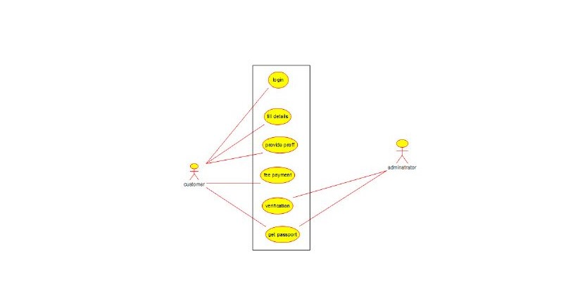

ACTIVITY DIAGRAM 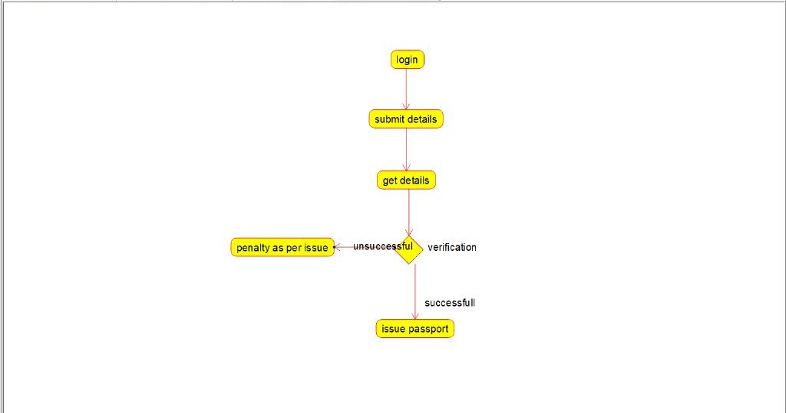

STATE DIAGRAM

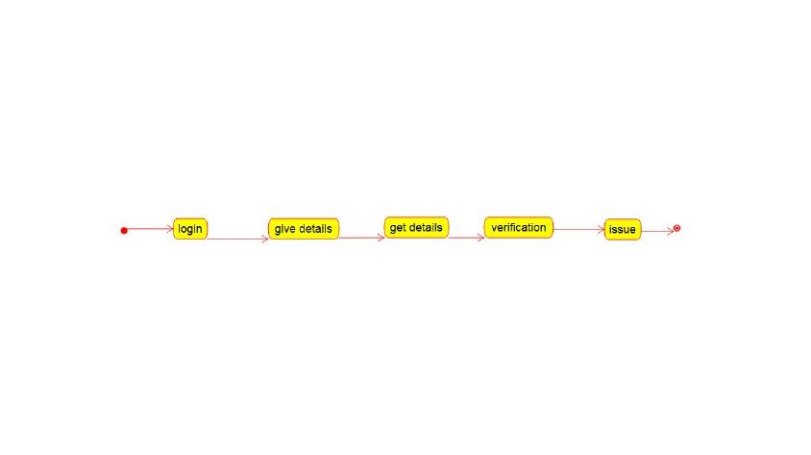

CLASS DIAGRAM

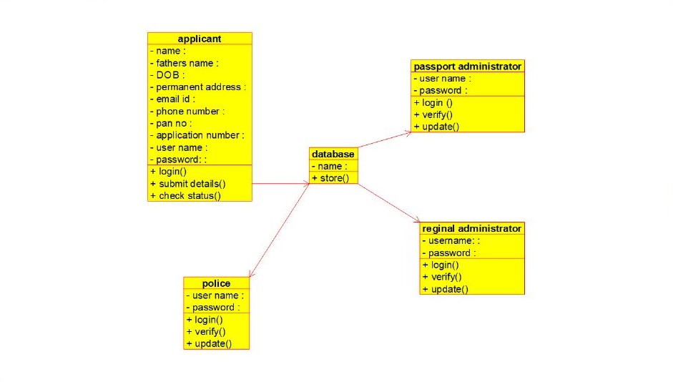

SEQUENCE DIAGRAM

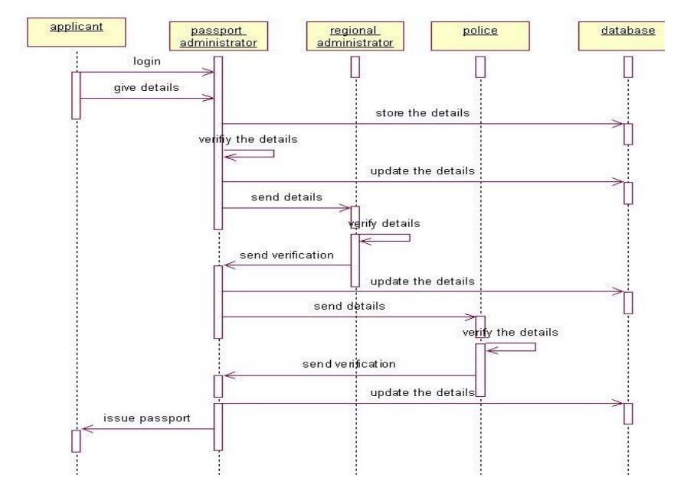  
COMPONENT DIAGRAM

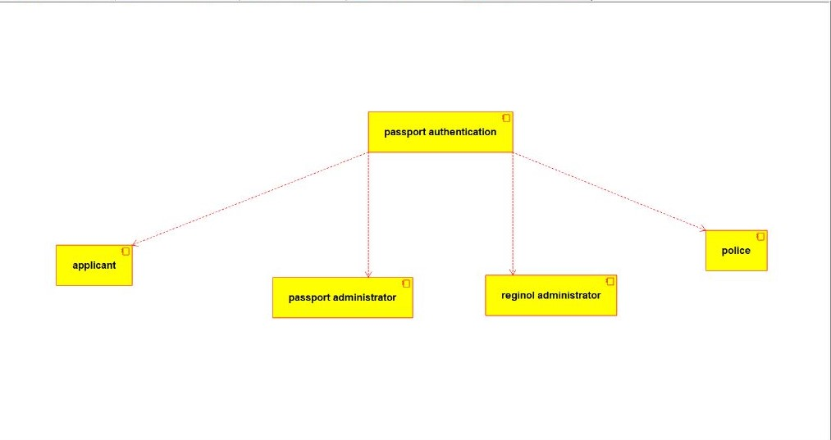

DEPLOYMENT DIAGRAM

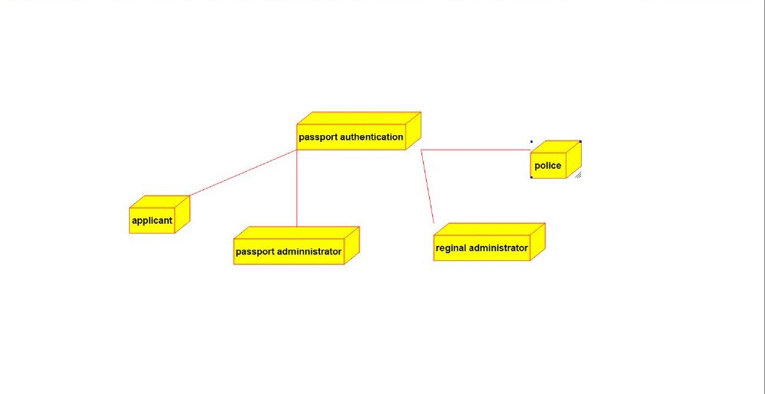

PACKAGE DIAGRAM

